**User Manual: Decision Table Builder**

**1. Introduction** The Decision Table Builder is a simple C++ desktop application that helps users generate decision tables based on provided conditions and actions. This tool is useful for software engineering students and professionals who need to visually map logical decision-making processes.

**2. System Requirements**

* Operating System: Windows, Linux, or macOS
* Terminal or command-line interface

**3. How to Use the Program**

Upon launching the program, follow the step-by-step prompts:

1. **Enter number of conditions** – Input the number of logical conditions involved in your scenario.
2. **Name each condition** – Provide a short name or label for each condition (e.g., "IsLoggedIn", "HasAccess").
3. **Enter number of actions** – Input the number of actions that could be taken depending on the conditions.
4. **Name each action** – Give each action a short descriptive label (e.g., "DisplayError", "SubmitForm").
5. The program will automatically generate all possible combinations of the conditions (as T/F) and display a blank decision table with space for action outputs.

**Example Walkthrough on next page.**

**Example Walkthrough**

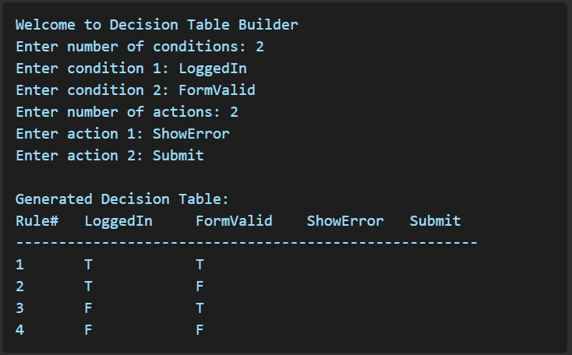

**5. Notes**

* The tool does not currently apply specific actions to each rule. Users can manually determine which actions apply per row based on logic.
* For larger condition sets (e.g., >10), the rule count may become too large for practical use in a terminal.

**6. Author and Contact** Developed by Bryce Chudzik, David Mack, Jack Orlowski for CIS 375 — Software Engineering I

For questions or suggestions, please contact the developers.